Proverbs 2:1-6 My son, if you accept my words and store up my commands within you, ² turning your ear to wisdom and applying your heart to understanding— ³ indeed, if you call out for insight and cry aloud for understanding, ⁴ and if you look for it as for silver and search for it as for hidden treasure, ⁵ then you will understand the fear of the LORD and find the knowledge of God.⁶ For the LORD gives wisdom; from his mouth come knowledge and understanding.
Daniel 9:1 In the first year of Darius son of Xerxes (a Mede by descent), who was made ruler over the Babylonian kingdom.
Vision 1 Daniel 7, Four beasts (lion, bear, leopard, hideous beast) Vision 2 Daniel 8, Ram & Goat (Medo/Persian empire & Grecian empire) Vision 3 Daniel 10-11 King of the South and King of the North “great war”
Daniel 10:19-21 “Do not be afraid, you who are highly esteemed,” he said. “Peace! Be strong now; be strong.” When he spoke to me, I was strengthened and said, “Speak, my lord, since you have given me strength.” ²⁰ So he said, “Do you know why I have come to you? Soon I will return to fight against the prince of Persia, and when I go, the prince of Greece will come; ²¹ but first I will tell you what is written in the Book of Truth. (No one supports me against them except Michael, your prince.

Four Generals after Alexander the Great,
- Seleucus, Syria KING OF THE NORTH
- Lysimachus, Thrace
- Cassander, Macedon
- Ptolemy, Egypt KING OF THE SOUTH
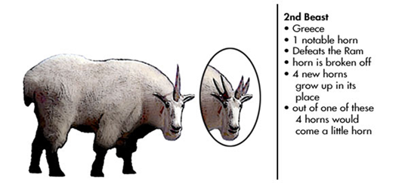

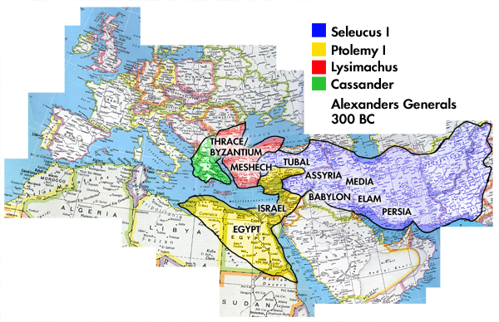
Daniel 11 kings and kingdoms
Daniel 11:16 MSG He'll march in big as you please, as if he owned the place. He'll take over that beautiful country, Palestine, and make himself at home in it.
Antiochus Epiphanes- “Antiochus the splendid or magnificent one” Antiochus Epimanes- “The madman”
1 Peter 4:12 do not be surprised at the fiery ordeal that has come on you to test you, as though something strange were happening to you.
Romans 5:3-5 Not only so, but we also glory in our sufferings, because we know that suffering produces perseverance; ⁴ perseverance, character; and character, hope.⁵ And hope does not put us to shame, because God’s love has been poured out into our hearts through the Holy Spirit, who has been given to us.
Proverbs 24:10 If you faint in the day of adversity, your strength is small.
Job 42:1-2 Then Job replied to the LORD: ² “I know that you can do all things; no purpose of yours can be thwarted.
Revelation 21:6 God is above all things and before all things. He is the alpha and the omega, the beginning and the end. He is immortal, and He is present everywhere so that everyone can know Him.
Colossians 1:16 God created all things and holds all things together, both in heaven and on earth, both visible and invisible
Romans 11:33 God knows all things past, present, and future. There is no limit to His knowledge, for God knows everything completely before it even happens.
“Sovereign” - the ultimate source of all power, authority, and everything that exists.
Summer Revelation study
May 9 (6:30-8:30pm every Tuesday evening
at
New Church 9201 N. Rockwell Ave, OKC )
May 10 (9:30-11:30 am every Wednesday morning
at
OKC LifeChurch campus 2001 NW 178th)
Please contact one of us to reserve your place.
Marci Cretsinger 405-989-6049 marcicret@gmail.com
Kathy Patton 405-620-1585 kathypatton16@gmail.com

