Psalm 100 Shout for joy to the LORD, all the earth. ² Worship the LORD with gladness; come before him with joyful songs. ³ Know that the LORD is God. It is he who made us, and we are his; we are his people, the sheep of his pasture. ⁴ Enter his gates with thanksgiving and his courts with praise; give thanks to him and praise his name. ⁵ For the LORD is good and his love endures forever; his faithfulness continues through all generations.
Psalm 23 The LORD is my shepherd, I lack nothing. ² He makes me lie down in green pastures, he leads me beside quiet waters, ³ he refreshes my soul. He guides me along the right paths for his name’s sake. ⁴ Even though I walk through the darkest valley, I will fear no evil, for you are with me; your rod and your staff, they comfort me. ⁵ You prepare a table before me in the presence of my enemies. You anoint my head with oil, my cup overflows. ⁶ Surely your goodness and love will follow me all the days of my life, and I will dwell in the house of the LORD forever.
Albert Einstein: The definition of insanity is doing the same thing over and over and expecting different results.
Daniel 4 Nebuchadnezzar’s dream of a tree.
Daniel 4:10-12
These are the visions I saw while lying in bed: I looked, and there before me stood a tree in the middle of the land. Its height was enormous. The tree grew large and strong and its top touched the sky;
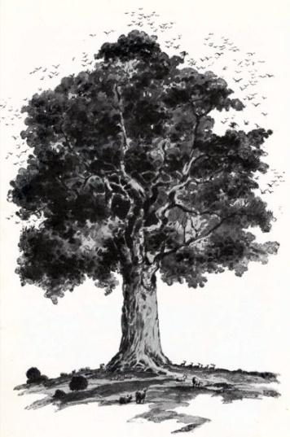

it was visible to the ends of the earth.
¹² Its leaves were beautiful, its fruit abundant, and on it was food for all. Under it the wild animals found shelter, and the birds lived in its branches; from it every creature was fed.

Now the terrifying part of the dream.
“In the visions I saw while lying in bed, I looked, and there before me was a holy one, a messenger, coming down from heaven.
14 He called in a loud voice: ‘Cut down the tree and trim off its branches; strip off its leaves and scatter its fruit. Let the animals flee from under it and the birds from its branches.

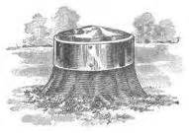
15 But let the stump and its roots, bound with iron and bronze, remain in the ground, in the grass of the field. “

Leaving the stump had great significance.
Job wrote about this in Job 14:7-9 “At least there is hope for a tree: If it is cut down, it will sprout again, and its new shoots will not fail. ⁸ Its roots may grow old in the ground and its stump die in the soil, ⁹ yet at the scent of water it will bud and put forth shoots like a plant.
Colossians 3:12-13 Therefore, as God’s chosen people, holy and dearly loved, clothe yourselves with compassion, kindness, humility, gentleness and patience. ¹³ Bear with each other and forgive one another if any of you has a grievance against someone. Forgive as the Lord forgave you.
Ephesians 4:31-32 Get rid of all bitterness, rage and anger, brawling and slander, along with every form of malice. ³² Be kind and compassionate to one another, forgiving each other, just as in Christ God forgave you.
Luke 11:28 “blessed, rather are those who hear the word of God and obey it.”
1 Peter 2:1 Therefore, rid yourselves of all malice and all deceit, hypocrisy, envy and slander of every kind.
1 Corinthians 6:18 Flee sexual immorality.
1 Corinthians 10:14 …flee idolatry.
2 Timothy 2:22 Flee the evil desires of youth and pursue righteousness, faith love and peace, along with those who call on the Lord out of a pure heart.
Daniel 4:20-22 The tree you saw, which grew large and strong, with its top touching the sky, visible to the whole earth, ²¹ with beautiful leaves and abundant fruit, providing food for all, giving shelter to the wild animals, and having nesting places in its branches for the birds—²² Your Majesty, you are that tree! You have become great and strong; your greatness has grown until it reaches the sky, and your dominion extends to distant parts of the earth.
Daniel 4:34-37 At the end of that time, I, Nebuchadnezzar, raised my eyes toward heaven, and my sanity was restored. Then I praised the Most High; I honored and glorified him who lives forever. His dominion is an eternal dominion; his kingdom endures from generation to generation. ³⁵ All the peoples of the earth are regarded as nothing. He does as he pleases with the powers of heaven and the peoples of the earth. No one can hold back his hand or say to him: “What have you done?”³⁶ At the same time that my sanity was restored, my honor and splendor were returned to me for the glory of my kingdom. My advisers and nobles sought me out, and I was restored to my throne and became even greater than before.³⁷ Now I, Nebuchadnezzar, praise and exalt and glorify the King of heaven, because everything he does is right and all his ways are just. And those who walk in pride he is able to humble.

