Daniel 2:19-21 Then Daniel praised the God of heaven²⁰ and said: “Praise be to the name of God for ever and ever; wisdom and power are his. ²¹ He changes times and seasons; he deposes kings and raises up others…
Colossians 3:23-24 ESV “Whatever you do, work heartily, as for the Lord and not for men, ²⁴ knowing that from the Lord you will receive the inheritance as your reward. You are serving the Lord Christ.”
Romans 12:18 If it is possible, as far as it depends on you, live at peace with everyone.
Romans 12:17 Repay no one evil for evil, but give thought to do what is honorable in the sight of all.
The world may not know the details of doctrine or the intimacies of worship with God, but they recognize a bad temper, selfishness, conceitedness, or dishonesty when they see it.
“The world is a very poor critic of my Christianity, but it is a very sufficient one of my conduct.” Alexander Maclaren
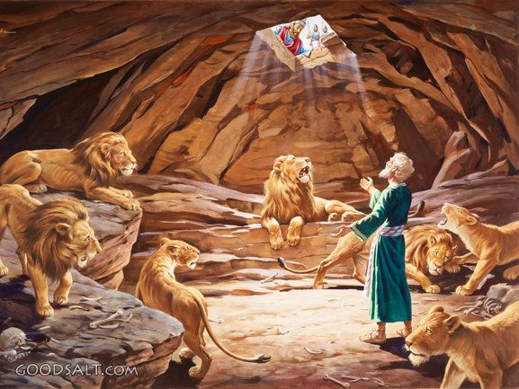
Daniel 6 In the lion’s den

1 Timothy 3:2-7 Now the overseer is to be above reproach, faithful to his wife, temperate, self-controlled, respectable, hospitable, able to teach,³ not given to drunkenness, not violent but gentle, not quarrelsome, not a lover of money. ⁴ He must manage his own family well and see that his children obey him, and he must do so in a manner worthy of full respect.⁵ (If anyone does not know how to manage his own family, how can he take care of God’s church?) ⁶ He must not be a recent convert, or he may become conceited and fall under the same judgment as the devil. ⁷ He must also have a good reputation with outsiders, so that he will not fall into disgrace and into the devil’s trap.
Craig Groeschel “Leadership is influence, and everyone has influence.”
A decree of the Medes and the Persians could not be changed. The law was the ultimate authority. Medo/Persian kings were thought to be gods, the gods could not be wrong so the law could not be changed.

“But God”
Psalm 73:26 “My flesh and my heart may fail, but God is the strength of my heart and my portion forever”
1 Corinthians 3:6 “I planted, Apollos watered, but God gave the growth”
Genesis 31:6-7 “You know that I have served your father with all my strength, yet your father has cheated me and changed my wages ten times. But God did not permit him to harm me.”
Genesis 45:8 “So it was not you who sent me here, but God. He has made me a father to Pharaoh, and lord of all his house and ruler over all the land of Egypt.”
1 Samuel 23:14 “And David remained in the strongholds in the wilderness, in the hill country of the wilderness of Ziph. And Saul sought him every day, but God did not give him into his hand.”

Jim Elliot quote taken from one of his journals. “He is no fool who gives what he cannot keep, to gain that which he cannot lose.”

John 12:24 Truly, truly, I say to you, unless a grain of wheat falls into the earth and dies, it remains alone; but if it dies, it bears much fruit.cam
Romans 12:1 Paul is speaking Therefore, I urge you, brothers and sisters, in view of God’s mercy, to offer your bodies as a living sacrifice.

