Valuable lessons from Daniel
- It is possible to live a faithful life even in a situation not of our choosing
- God is always faithful.
- God opposes the proud, but he gives grace to the humble. Even kings are under his authority.
- This is not heaven, do not be surprised at trials.
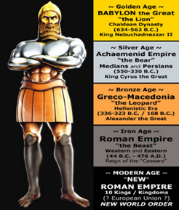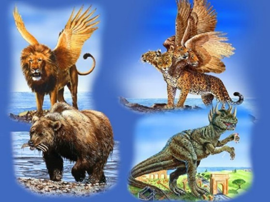

Daniel’s name means “God is my Judge.”
What do we know about angelic beings?
- We know that 1/3 of them fell with Satan when he rebelled against God and yet there are still thousands upon thousands of them.
- They are powerful.
- They constantly praise & worship God.
- They serve as God’s messengers.
- They are ministering spirits, providing protection and direction for God’s people.

Revelation 20:12
And I saw the dead, great and small, standing before the throne, and books were opened. Then another book was opened, which is the book of life. And the dead were judged by what was written in the books, according to what they had done.
This term Son of Man was the way Jesus referred to himself most often.
Matthew 8:20 Jesus replied, “Foxes have dens and birds have nests, but the Son of Man has no place to lay his head.”
Matthew 9:2-6 Some men brought to him a paralyzed man, lying on a mat. When Jesus saw their faith, he said to the man, “Take heart, son; your sins are forgiven. ³ At this, some of the teachers of the law said to themselves, “This fellow is blaspheming!” ⁴ Knowing their thoughts, Jesus said, “Why do you entertain evil thoughts in your hearts? ⁵ Which is easier: to say, ‘Your sins are forgiven,’ or to say, ‘Get up and walk’? ⁶ But I want you to know that the Son of Man has authority on earth to forgive sins.” So he said to the paralyzed man, “Get up, take your mat and go home.”
Matthew 12:40 For as Jonah was three days and three nights in the belly of a huge fish, so the Son of Man will be three days and three nights in the heart of the earth.
Matthew 17:22 When they came together in Galilee, he said to them, “The Son of Man is going to be delivered into the hands of men.
Luke 21:27 ²⁷ At that time they will see the Son of Man coming in a cloud with power and great glory.
Matthew 24:27-30 For as lightning that comes from the east is visible even in the west, so will be the coming of the Son of Man.²⁸ Wherever there is a carcass, there the vultures will gather. ²⁹ “Immediately after the distress of those days “ ‘the sun will be darkened, and the moon will not give its light; the stars will fall from the sky, and the heavenly bodies will be shaken.’ ³⁰ “Then will appear the sign of the Son of Man in heaven. And then all the peoples of the earth will mourn when they see the Son of Man coming on the clouds of heaven, with power and great glory.
Matthew 26:63-64 But Jesus remained silent. The high priest said to him, “I charge you under oath by the living God: Tell us if you are the Messiah,(the Christ) the Son of God.” ⁶⁴ “You have said so,” Jesus replied. “But I say to all of you: From now on you will see the Son of Man sitting at the right hand of the Mighty One and coming on the clouds of heaven.”
Knowing all of this we can rejoice!!! We know how this story ends. We know who is victorious.
The point of this prophecy is not to confuse…it is to comfort.
Let’s thank God for opening the curtain of his plan far enough that we can say, it is well with my soul!
What are we to do?
- Be thankful.
- Trust God.
- Rejoice knowing God sees us.
- Pray continually.

