1 Peter 3:15 Always be prepared to give an answer to everyone who asks you to give the reason for the hope that you have. But do this with gentleness and respect,
1 Thessalonians 5:4-5 But you, brothers and sisters, are not in darkness so that this day should surprise you like a thief. 5 You are all children of the light and children of the day.
Four beasts who rise to positions of power.
World Empires | Daniel 2 | Daniel 7 | Daniel 8
Babylon | Head of gold | Lion with eagle’s wings
Medo/Persian | Chest and arms of silver | Bear, with 3 ribs in his mouth given permission to devour | Ram with 2 horns
Greece | Waist and hips of bronze | Leopard, 4 wings, 4 heads swift and given authority to rule | Goat 1 horn between its eyes
Rome | Legs of iron | Indescribable beast, iron teeth, it crushed and devoured everything. It was different from all the others. 10 horns, a little horn came up and uprooted 3 of the 10. He had eyes like a man and a mouth that spoke boastfully.
 | Daniel is young man | Young man+55 years | Young man + 58 years
 | 2nd year of King Nebuchadnezzar | 1st year of King Belshazzar | 3rd year of King Belshazzar
 | King has a dream | Daniel has a vision | Daniel has a vision

Isaiah 45:1-3 Thus says the LORD to his anointed, to Cyrus, whose right hand I have grasped, to subdue nations before him and to loose the belts of kings, to open doors before him that gates may not be closed: ² "I will go before you and level the exalted places, I will break in pieces the doors of bronze and cut through the bars of iron, ³ I will give you the treasures of darkness and the hoards in secret places, that you may know that it is I, the LORD, the God of Israel, who call you by your name.

1. Asia minor -Lysimachus
2. Greece and Macedonia-Cassander (Antigonus)
3. Egypt (South)- Ptolemy
4. Syria Persia & India (North) Seluccus
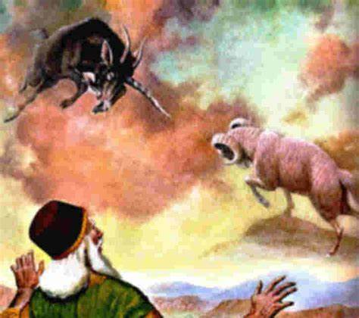
Ram represents the Medo-Persian Empire Goat represents the Grecian Empire
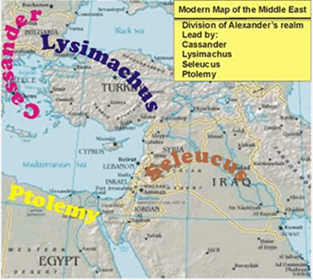

The Principle of Double Reference
Dr. David Jeremiah “To speak of the law of double reference is to speak of interpretation, not application. Double reference is not one interpretation and manifold applications. It is one message for two audiences separated in time.”

The 2300 evening and morning of Daniel 8:14
Genesis 1:5 And the evening and the morning were the first day.
Genesis 1:8 And the evening and the morning were the second day.
Genesis 1:13 And the evening and the morning were the third day.
Genesis 1:19 And the evening and the morning were the fourth day.
Genesis 1:23 And the evening and the morning were the fifth day.
Genesis 1:31 And the evening and the morning were the sixth day.

2 Peter 3:14-16 ESV Therefore, beloved, since you are waiting for these, be diligent to be found by him without spot or blemish, and at peace. ¹⁵ And count the patience of our Lord as salvation, just as our beloved brother Paul also wrote to you according to the wisdom given him, ¹⁶ as he does in all his letters when he speaks in them of these matters. There are some things in them that are hard to understand, which the ignorant and unstable twist to their own destruction, as they do the other Scriptures.
John Piper from the article “You do not need to understand everything now.” “The Bible reveals some things we find extraordinarily hard to understand — inscrutable things that perplex, confound, and even disturb us. But nature reveals traces of the same designer. When we run up against conundrums that show us the limits of our intellectual capacities, we don’t need to follow cynical doubts. But like Paul, our limits can lead us to awe-filled worship.”
Romans 11:33-34 Oh, the depth of the riches and wisdom and knowledge of God! How unsearchable are his judgments and how inscrutable his ways! “For who has known the mind of the Lord?”

