This chapter can be easily divided into two sections.
- Daniel 9:1-19 Daniel’s prayer
- Daniel 9: 20-27 Gabriel’s explanation of events to come.
Deuteronomy 11:1-5 Love the LORD your God and keep his requirements, his decrees, his laws and his commands always. ² Remember today that your children were not the ones who saw and experienced the discipline of the LORD your God: his majesty, his mighty hand, his outstretched arm; ³ the signs he performed and the things he did in the heart of Egypt, both to Pharaoh king of Egypt and to his whole country; ⁴ what he did to the Egyptian army, to its horses and chariots, how he overwhelmed them with the waters of the Red Sea as they were pursuing you, and how the LORD brought lasting ruin on them. ⁵ It was not your children who saw what he did for you in the wilderness until you arrived at this place,
Deuteronomy 11:18-21 Fix these words of mine in your hearts and minds; tie them as symbols on your hands and bind them on your foreheads. ¹⁹ Teach them to your children, talking about them when you sit at home and when you walk along the road, when you lie down and when you get up. ²⁰ Write them on the doorframes of your houses and on your gates,²¹ so that your days and the days of your children may be many in the land the LORD swore to give your ancestors, as many as the days that the heavens are above the earth.
Deuteronomy 11: 26-28 See, I am setting before you today a blessing and a curse—²⁷ the blessing if you obey the commands of the LORD your God that I am giving you today; ²⁸ the curse if you disobey the commands of the LORD your God and turn from the way that I command you today by following other gods, which you have not known.
The Law of First Mention-when studying scripture, we should look for the first time something is mentioned to gain a greater understanding. The first mention is the simplest and most clear presentation and then later it is more fully developed on that foundation.
Genesis 29:27-28 Finish this daughter’s bridal week; then we will give you the younger one also, in return for another seven years of work.” ²⁸ And Jacob did so. He finished the week with Leah, and then Laban gave him his daughter Rachel to be his wife.
2 Corinthians 5:21 God made him who had no sin to be sin for us, so that in him we might become the righteousness of God.
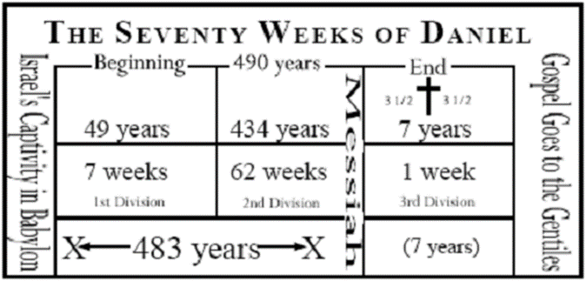

Serving & Ministry ideas
- Project 66 (non-perishable food items or personal hygiene products, paper sacks) You may bring your items to WTW, Angie Mote and Shawna Mayfield volunteer weekly will be happy to take them over. Project 66 also takes financial donations to purchase food items at a highly discounted price (8-10 cents per pound) from the Regional Food Bank.
- Logan county fire victims, give money or gift cards to help the victims. Several of our ladies know people who lost everything.
- Senior Activity Center Bring plastic store bags which will be used to knit mats for the homeless.

Changed Retreat 2023 April 20 - April 23, Camp WOW (Walk on Water) Stuart, OK
Do you need a break from the everyday busyness?
Do you struggle with a lack of self-confidence?
Do you have an internal dialogue that is borderline abusive?
Do you let past hurts keep you from trusting others and loving completely?
If you can answer "yes" to any of these questions, then register today for the Changed Women's Retreat!
The Changed Women's Retreat is an opportunity for any woman, no matter what age or stage of life, to get away from the demands of the world and press in closer to Jesus. Closer to Him where we can begin to see ourselves as He sees us. To the place where we begin to understand that our identity is in Christ and not what the world says we could or should be. The place where we feel loved, cherished, and pursued by God. The confidence that comes from knowing and believing these things empowers us to play our irreplaceable role in this world.
For more information visit https://www.changedokc.com

