The Persian Empire
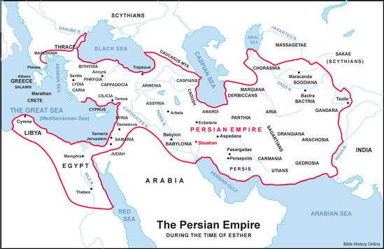
Cyrus ruled 559-530 B.C.
Isaiah prophesied from 739-686 BC
Isaiah 44:24-28 “This is what the LORD says— your Redeemer, who formed you in the womb: I am the LORD, the Maker of all things, who stretches out the heavens, who spreads out the earth by myself, ²⁵ who foils the signs of false prophets and makes fools of diviners, who overthrows the learning of the wise and turns it into nonsense, ²⁶ who carries out the words of his servants and fulfills the predictions of his messengers, who says of Jerusalem, ‘It shall be inhabited,’ of the towns of Judah, ‘They shall be rebuilt,’ and of their ruins, ‘I will restore them,’ ²⁷ who says to the watery deep, ‘Be dry, and I will dry up your streams,’ ²⁸ who says of Cyrus, ‘He is my shepherd and will accomplish all that I please; he will say of Jerusalem, “Let it be rebuilt,” and of the temple, “Let its foundations be laid.” ’
Isaiah 45:1-3 “This is what the LORD says to his anointed, to Cyrus, whose right hand I take hold of to subdue nations before him and to strip kings of their armor, to open doors before him so that gates will not be shut: ² I will go before you and will level the mountains ; I will break down gates of bronze and cut through bars of iron. ³ I will give you hidden treasures, riches stored in secret places, so that you may know that I am the LORD, the God of Israel, who summons you by name.

Know-Hebrew word Yada, to know by experience.
Daniel 1:21 “thus Daniel continued until the first year of King Cyrus.”

Think for a minute, who are some of the people who had an impact on your life helping you to know God?
Are you that person for others?

King Cyrus issues a decree, any of the Israelites who want to go back to Jerusalem may go and rebuild the temple. King Cyrus grants permission and provision.

Daniel 1:2 And the Lord delivered Jehoiakim king of Judah into his hand, along with some of the articles from the temple of God. These he carried off to the temple of his god in Babylonia and put in the treasure house of his god.

Practice rejoicing at the work of God!
Beware of comparisons.
Comparisons sabotage the work and steal other’s confidence.
Comparisons are often unfair; they place attention on the wrong thing.

Philippians 3:13 I do not consider myself yet to have taken hold of it. But one thing I do: Forgetting what is behind and straining toward what is ahead,
Philippians 4:8 Finally, brothers and sisters, whatever is true, whatever is noble, whatever is right, whatever is pure, whatever is lovely, whatever is admirable—if anything is excellent or praiseworthy—think about such things.

