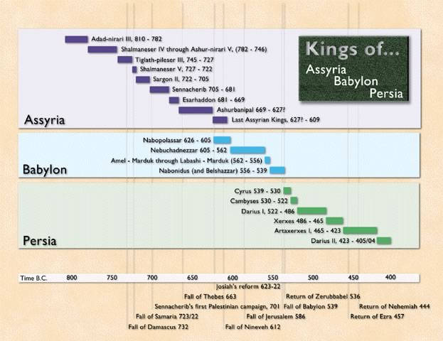
- The Israelites have been in ___________ captivity.
- How many years were they in captivity? ___________
- Jeremiah prophesied were read to King ________. He made a decree that any who had a heart to return to Jerusalem could go.
- The first leader was____________.
- He led approximately __________people back to Jerusalem.
- As we saw it was a difficult assignment because the city was in rubble, but they also faced repeated opposition. It took them nearly ____________years to complete the work.
- When the work was completed, they enjoyed their first _________________celebration in the land.
- This week we looked at the second leader to bring a group of Israelites back to Jerusalem. _________, the author of these two books. Now it is King Artaxerxes who is inspired by God to allow more people to return.
Ezra devoted himself NIV Hebrew word Kuwn Verb, an action word. Prepared his heart KJV It means to firmly establish, to be fixed, to make firm, ready,
Ezra had taken the necessary steps to prepare his heart to seek and to hear from God.
Steps we can take to follow Ezra’s example and prepare our heart to study and apply God’s word.
  - Prioritize time with God
  - Pray
  - Take time to listen.
  - Purify our heart.
James 1:22-25 Do not merely listen to the word, and so deceive yourselves. Do what it says. ²³ Anyone who listens to the word but does not do what it says is like someone who looks at his face in a mirror ²⁴ and, after looking at himself, goes away and immediately forgets what he looks like.²⁵ But whoever looks intently into the perfect law that gives freedom, and continues in it—not forgetting what they have heard, but doing it—they will be blessed in what they do.

Matthew 28:18-20 Then Jesus came to them and said, “All authority in heaven and on earth has been given to me. ¹⁹ Therefore go and make disciples of all nations, baptizing them in the name of the Father and of the Son and of the Holy Spirit,²⁰ and teaching them to obey everything I have commanded you. And surely I am with you always, to the very end of the age.”

2 Timothy 2:15 Do your best to present yourself to God as one approved, a worker who does not need to be ashamed and who correctly handles the word of truth.

1 Peter 4:10 Each of you should use whatever gift you have received to serve others, as faithful stewards of God’s grace in its various forms.

What has God called you to do?

Do you have a plan?

Do you involve others in the joy of carrying out God’s work?

Do you remember to rejoice throughout the adventure of serving God?

