R.C. Sproul “God is trustworthy. We must come to rest with the God who is sovereign.”
Leviticus 18; Deuteronomy 13; 18:9-14 (Laws and standards for the Israelites concerning the evil practices of the other nations around them.)
Psalm 126:6 ESV He who goes out weeping, bearing the seed for sowing, shall come home with shouts of joy, bringing his sheaves with him.
In the New Testament we see believers are instructed to be very careful who they marry.
2 Corinthians 6:14 Do not be yoked together with unbelievers.

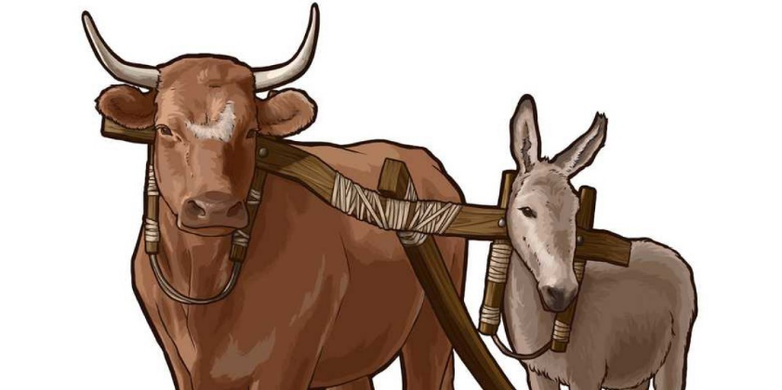
To be yoked refers to two animals that are joined by a wooden bar. Being unequally yoked means that the two are not equal in strength. The yoke would rub them both the wrong way. This would make their plowing together much more difficult.

1 Corinthians 7:12-14 If any brother has a wife who is not a believer and she is willing to live with him, he must not divorce her. ¹³ And if a woman has a husband who is not a believer and he is willing to live with her, she must not divorce him. ¹⁴ For the unbelieving husband has been sanctified through his wife, and the unbelieving wife has been sanctified through her believing husband. Otherwise your children would be unclean, but as it is, they are holy.
Sanctified - set apart for God’s use.
Holy – set apart for the purposes of God.
This may be our greatest opportunity to display the grace of God.
1 Corinthians 7:39 A woman is bound to her husband as long as he lives. But if her husband dies, she is free to marry anyone she wishes, but he must belong to the Lord.
We are back to where we started today.
What do we know of the character of our God? Are we studying His word so that we will know him more? Are we being transformed to the image of Christ?
