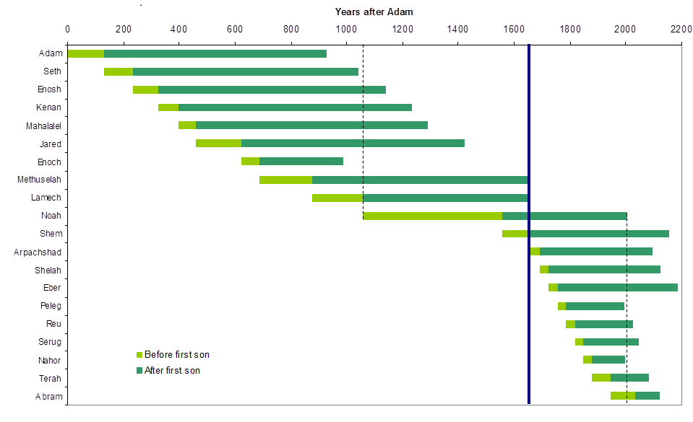
Genesis 1:31 God saw all that he had made, and it was very good. And there was evening, and there was morning—the sixth day.
Genesis 11:31-32 Terah took his son Abram, his grandson Lot son of Haran, and his daughter-in-law Sarai, the wife of his son Abram, and together they set out from Ur of the Chaldeans to go to Canaan. But when they came to Harran, they settled there. 32 Terah lived 205 years, and he died in Harran.
Genesis 12:1 The LORD had said to Abram, “Go from your country, your people and your father’s household to the land I will show you.² “I will make you into a great nation, and I will bless you; I will make your name great, and you will be a blessing.³ I will bless those who bless you, and whoever curses you I will curse; and all peoples on earth will be blessed through you.”⁴ So Abram went, as the LORD had told him; and Lot went with him. Abram was seventy-five years old when he set out from Harran. ⁵ He took his wife Sarai, his nephew Lot, all the possessions they had accumulated and the people they had acquired in Harran, and they set out for the land of Canaan, and they arrived there.

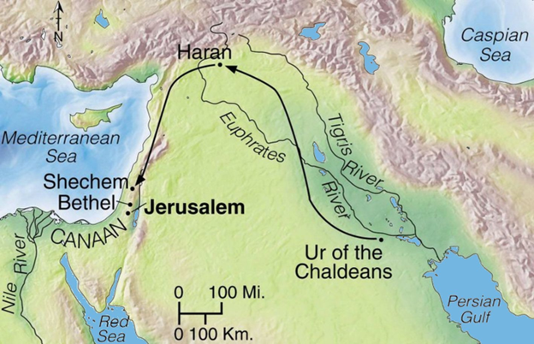
Genesis 17:1-14 When Abram was ninety-nine years old, the LORD appeared to him and said, “I am God Almighty ; walk before me faithfully and be blameless. ² Then I will make my covenant between me and you and will greatly increase your numbers.” ³ Abram fell facedown, and God said to him, ⁴ “As for me, this is my covenant with you: You will be the father of many nations. ⁵ No longer will you be called Abram ; your name will be Abraham, for I have made you a father of many nations. ⁶ I will make you very fruitful; I will make nations of you, and kings will come from you. ⁷ I will establish my covenant as an everlasting covenant between me and you and your descendants after you for the generations to come, to be your God and the God of your descendants after you. ⁸ The whole land of Canaan, where you now reside as a foreigner, I will give as an everlasting possession to you and your descendants after you; and I will be their God.” ⁹ Then God said to Abraham, “As for you, you must keep my covenant, you and your descendants after you for the generations to come. ¹⁰ This is my covenant with you and your descendants after you, the covenant you are to keep: Every male among you shall be circumcised. ¹¹ You are to undergo circumcision, and it will be the sign of the covenant between me and you. ¹² For the generations to come every male among you who is eight days old must be circumcised, including those born in your household or bought with money from a foreigner—those who are not your offspring. ¹³ Whether born in your household or bought with your money, they must be circumcised. My covenant in your flesh is to be an everlasting covenant. ¹⁴ Any uncircumcised male, who has not been circumcised in the flesh, will be cut off from his people; he has broken my covenant.”
Genesis 21:5 When Abraham was 100, Isaac was born.
Genesis 25:26 When Isaac was 60, Esau and Jacob were born.
Genesis 28:12-15 God established his promises through Jacob.
Genesis 29 Jacob’s two wives and two handmaids bear twelve sons. Joseph (son by Rachel) sold into slavery
Genesis 49:26-27 Jacob and his family move to Egypt (66 persons in all)
Exodus 1:8-9 New king who did not know about Joseph and all he did.
Exodus 3:10 Israelites had multiplied, Egyptians fear their numbers and oppress them.
Exodus 9-11 God sent ten plagues.
Exodus 31 God gave Moses ten commandments.
Exodus 32 Israelites make a golden calf.
Deuteronomy 1:35 Wandering forty years.
Deuteronomy 34:7 Moses died at 120 years old.
Joshua 1:24 Joshua led the people into the promised land, died at 110 years old.
Judges 21:25 “In those days Israel had no king: everyone did what seemed right in his own eyes.”
1 Samuel 8:6-7 Israelites demand a king. To be like all the other nations.
1 Kings 12:10-11, 28-33 Rehoboam listened to bad advice. Nation of Israel split. Jeroboam sets up two places of worship, Dan and Bethel. (This was never God’s plan) God allows the Assyrians to take northern tribes captive.
Daniel 1 opens with Jeroboam king of Judah. Babylonians come in three sieges and take Judah captive. (605 BC, 597BC, 586 BC)

