Luke 8 the parable of the soils
- Hard path
- Among the rocks
- Among the thorns
- Good soil
Results-100x’s harvest
Isaiah 6: 1-8
“In the year that King Uzziah died, I saw the Lord, high and exalted, seated on a throne; and the train of his robe filled the temple. 2 Above him were seraphim, each with six wings: With two wings they covered their faces, with two they covered their feet, and with two they were flying. 3 And they were calling to one another: “Holy, holy, holy is the LORD Almighty; the whole earth is full of his glory.” 4 At the sound of their voices the doorposts and thresholds shook and the temple was filled with smoke. 5 “Woe to me!” I cried. “I am ruined! For I am a man of unclean lips, and I live among a people of unclean lips, and my eyes have seen the King, the LORD Almighty.” 6 Then one of the seraphim flew to me with a live coal in his hand, which he had taken with tongs from the altar. 7 With it he touched my mouth and said, “See, this has touched your lips; your guilt is taken away and your sin atoned for.” 8 Then I heard the voice of the Lord saying, “Whom shall I send? And who will go for us?” And I said, “Here am I. Send me!”
When we come into the presence of the Lord Almighty, (El Shaddai) we will experience ______________, then _______________, and we will be ________________________.

Psalm 23:4 “even though I walk through the valley of the shadow of death, I will fear no evil, for you are with me.”
Hebrews 11:6 “Without faith it is impossible to please God.”
John 14:27 “Peace I leave with you, my peace I give unto you: not as the world giveth, give I unto you. Let not your heart be troubled, neither let it be afraid.”
2 Corinthians 13:11 Finally, brothers, rejoice. Aim for restoration, comfort one another, agree with one another, live in peace; and the God of love and peace will be with you.

Let’s commit to finding and doing a random act of kindness for someone else.

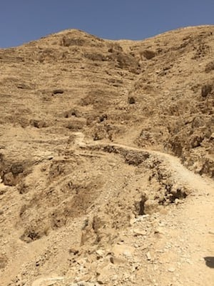
The road from Jerusalem down to Jericho.

The road from Jericho up to Jerusalem is approximately 20 miles long. It is a steep uphill climb with a change in elevation, Jerusalem is 2557.26 feet, and the elevation of Jericho is -825.31 feet. One can walk with little difficulty from Jerusalem to Jericho in 1 day, but if you are walking from Jericho to Jerusalem, it can take 2 days, because of the heat and the elevation change.

Are you ever so busy you get fussy?
Are you too busy to sit at Jesus feet?
Are you willing to sit quietly so you can hear from Jesus personally?
What is the longest you have ever sat quietly waiting on the Lord to speak to your heart?
Do you remember the command we were given in Luke 9:35?
Psalm 46:10 “Be still and know that I am God.”

