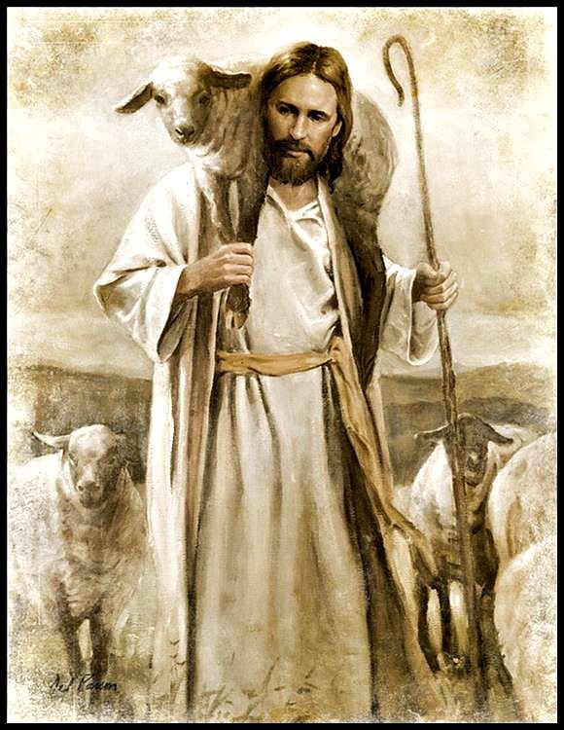

Phillip Keller, “A Shepherd Looks at Psalm 23”
Excerpt, page 20
In memory I can still see one of the sheep ranches in our district which was operated by a tenant sheepman. He ought never to have been allowed to keep sheep. His stock were always thin, weak, and riddled with disease or parasites. Again and again, they would come and stand at the fence staring blankly through the woven wire at the green, lush pastures my flock enjoyed. Had they been able to speak I am sure they would have said, “Oh, to be set free from this awful owner!”
This is a picture which has never left my memory. It is a picture of pathetic people the world over who have not known what it is to belong to the Good Shepherd…who suffer instead under sin and Satan.”

Proverbs 19:4 (ESV) Wealth brings many new friends, but a poor man is deserted by his friend.
Ephesians 2:8-9 (NIV) For it is by grace you have been saved, through faith-and this is not from yourselves, it is the gift of God-not by works, so that no one can boast.
Blue Letter Bible Notes on these three parables.
Each scene illustrates a different aspect of God's work.
- The Son seeks the lost as the Good Shepherd.
- The Holy Spirit seeks the lost with searching illumination.
- The Father seeks the lost with open arms upon return.
Each scene illustrates an increasing severity of loss.
- Of the sheep, 1% were lost.
- Of the coins, 10% were lost.
- Of the sons, 50% were lost.
Each scene illustrates a different way of being lost.
- The sheep was lost by foolish wandering, and so are many people today.
- The coin was lost by carelessness, not valuing it as we should.
- The son was lost because of rebellion, a rebellious departure required a submissive return by the lost one.

