Sycamore tree in Israel

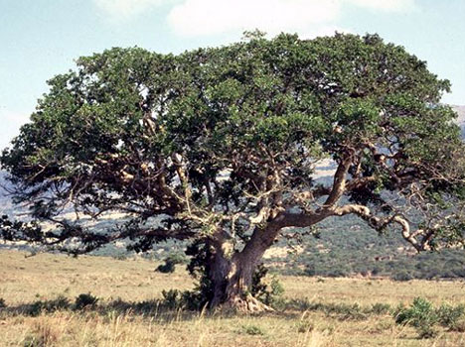
Luke 19:1-4 Jesus entered Jericho and was passing through.² A man was there by the name of Zacchaeus; he was a chief tax collector and was wealthy.³ He wanted to see who Jesus was, but because he was short he could not see over the crowd.⁴ So he ran ahead and climbed a sycamore-fig tree to see him, since Jesus was coming that way.

Verse 3, “to see” Greek word Eido, to see with the eyes, to turn one’s eyes, mind, and attention to someone or something, to observe, inspect, examine or to experience.
Zacchaeus, curious seeker, short in stature, undeterred and creative, covert.
The point of Jesus parable is stewardship of what we have been entrusted with matters to God.
2 Corinthians 5:10 (NIV) For we must all appear before the judgment seat of Christ, so that each of us may receive what is due us for the things done while in the body, whether good or bad.
John Maxwell “You can go from failure to success, but no one goes from excuses to success.”
Andy Stanley “We can fail our way to success, but we cannot excuse our way to success. A good miss can be a necessary step to figure out how to move forward.”
1 Corinthians 15:58 (ESV) Therefore, my beloved brothers, be steadfast, immovable, always abounding in the work of the Lord, knowing that in the Lord your labor is not in vain.
Galatians 6:9 (ESV) And let us not grow weary of doing good, for in due season we will reap, if we do not give up.

What’s your mina?
What are we doing with what we have been given?

