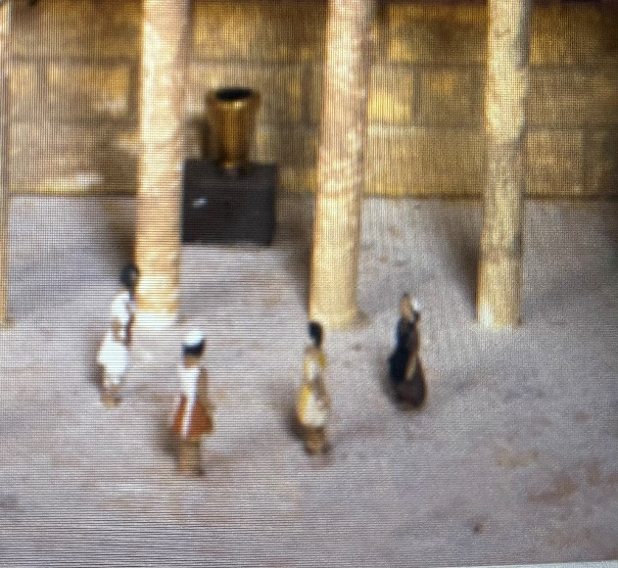

There were several chests in various locations in the Court of the Women. (some of the commentaries say it could have been as many as 13 chests) The Court of the Women was the area where women were allowed at the temple.

**Matthew 6:1** “Be careful not to practice your righteousness in front of others to be seen by them. If you do, you will have no reward from your Father in heaven.”

**Eleemosune**-righteousness, charity, alms, giving

**2 Corinthians 8:3-5** For I testify that they gave as much as they were able, and even beyond their ability. Entirely on their own, 4 they urgently pleaded with us for the privilege of sharing in this service to the Lord’s people. 5 And they exceeded our expectations: They gave themselves first of all to the Lord, and then by the will of God also to us.

**2 Corinthians 8:7** But since you excel in everything—in faith, in speech, in knowledge, in complete earnestness and in the love we have kindled in you —see that you also excel in this grace of giving.

**2 Corinthians 9:2** For I know your eagerness to help, and I have been boasting about it to the Macedonians, telling them that since last year you in Achaia were ready to give; and your enthusiasm has stirred most of them to action.

**2 Corinthians 9:6-7** Remember this: Whoever sows sparingly will also reap sparingly, and whoever sows generously will also reap generously.

**Romans 5:1-5** *Therefore, since we have been justified through faith, we have peace with God through our Lord Jesus Christ, 2 through whom we have gained access by faith into this grace in which we now stand. And we boast in the hope of the glory of God. 3 Not only so, but we also glory in our sufferings, because we know that suffering produces perseverance; 4 perseverance, character; and character, hope. 5 And hope does not put us to shame, because God’s love has been poured out into our hearts through the Holy Spirit, who has been given to us.*

**Prophetic Double Reference.**

The Bible includes prophecies which seem to focus on the immediate historical context of the prophet, yet which speak of a more complete fulfillment later. This tendency to speak of events that are separated by time, as though they were not, **is called the principle of double reference**.

The **near future** destruction of Jerusalem was done in AD 70 and foreshowed the Great Tribulation of the **distant future**.

**Jeremiah 30:7** (NIV) How awful that day will be! No other will be like it. **It will be a time of trouble for Jacob**, but he will be saved out of it.

**Matthew 24:26-31 (NIV)** “So if anyone tells you, ‘There he is, out in the wilderness,’ do not go out; or, ‘Here he is, in the inner rooms,’ do not believe it. 27 For as lightning that comes from the east is visible even in the west, so will be the coming of the Son of Man. 28 Wherever there is a carcass, there the vultures will gather. 29 “Immediately after the distress of those days “ ‘the sun will be darkened, and the moon will not give its light; the stars will fall from the sky, and the heavenly bodies will be shaken.’ 30 “Then will appear the sign of the Son of Man in heaven. And then all the peoples of the earthwill mourn when they see the Son of Man coming on the clouds of heaven, with power and great glory. 31 And he will send his angels with a loud trumpet call, and they will gather his elect from the four winds, from one end of the heavens to the other.

**Revelation 21:1-3 (NIV)** Then I saw “a new heaven and a new earth,” for the first heaven and the first earth had passed away, and there was no longer any sea. 2 I saw the Holy City, the new Jerusalem, coming down out of heaven from God, prepared as a bride beautifully dressed for her husband. 3 And I heard a loud voice from the throne saying, “Look! God’s dwelling place is now among the people, and he will dwell with them. They will be his people, and God himself will be with them and be their God.

Jesus came the first time to pay the ransom for our sins on the cross.

The next time he comes it will be in the clouds to catch us up. He will not come all the way to earth.

The next return of Jesus will be after the great tribulation. He will rule and reign.