Details for the Passover from Exodus
Action | Time | Scripture
Choose a lamb | 10th of Abib/Nisan | Exodus 12:3
Kill lamb | Twilight 14th of Abib/Nisan | Exodus 12:6
Put blood on doorposts | Evening | Exodus 12:7
Striking of Egyptian firstborn | About midnight | Exodus 12:29
Israelites not allowed out of homes | Until morning | Exodus 12:22
Israelites grab dough and clothes | Next morning | Exodus 12:34
Egyptians granted whatever they requested. | Morning | Exodus 12:36
Israelites gather to leave | Daytime | Exodus 13:18
Israelites leave Egypt | Sometime that day | Numbers 33:3
Keeping the Days of Unleavened Bread | Sunset 15th to sunset 21st of Abib/ Nisan | Exodus 12:17-19  Leviticus 23:6

The ESV notes: Abib-Preexile, Nisan-Postexile

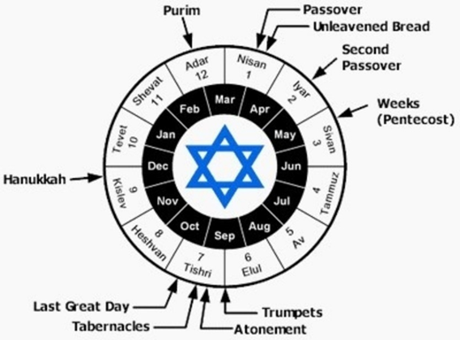
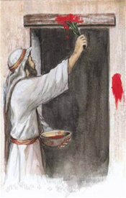

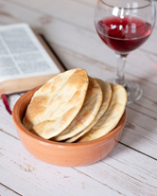
When we read of these events, we must remember that not everyone reckoned the days in the same way. This issue can be resolved when one considers the definition of a day.
Commentaries say the Galileans used a different method of reckoning the Passover than the Judeans. The Galileans used sunrise-to-sunrise to speak of a day. The Judeans used sunset-to-sunset as a day.
The chart below reveals how this can explain the discrepancy and how Jesus the Galilean could have celebrated the Passover with his disciples on Thursday and yet been slain as the Paschal Lamb on Friday.
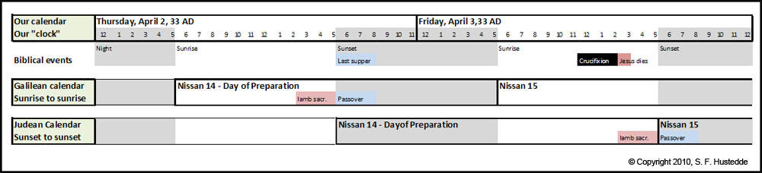
Notes and verses for Luke 22
Proximity does not equal a relationship.
We are no match for Satan.
1 Corinthians 6:18 Flee sexual immorality
2 Timothy 2:22 Flee youthful passions & pursue righteousness, faith, love & peace
1 Corinthians 15:33 Flee bad company it corrupts good morals
Ephesians 5:11 Flee the unfruitful works of darkness
Colossians 3:5 Flee sexual immorality, impurity, passion, evil desires, covetousness, which is idolatry. Putting anything before our holy God.
Divine sovereignty never negates (nullifies) human responsibility or accountability.
John 12:3-8 Then Mary took about a pint of pure nard, an expensive perfume; she poured it on Jesus’ feet and wiped his feet with her hair. And the house was filled with the fragrance of the perfume. 4 But one of his disciples, Judas Iscariot, who was later to betray him, objected, 5 “Why wasn’t this perfume sold and the money given to the poor? It was worth a year’s wages. ” 6 He did not say this because he cared about the poor but because he was a thief; as keeper of the money bag, he used to help himself to what was put into it. 7 “Leave her alone,” Jesus replied. “It was intended that she should save this perfume for the day of my burial. 8 You will always have the poor among you, but you will not always have me.”
There are many different leadership styles and capacities but one thing they should all have in common is a servant’s heart, like Jesus.
Sift, (Siniazo)- by inward agitation to try one's faith to the verge of overthrow.
Jeremiah 17:9 The heart is deceitful above all things, and desperately wicked; who can know it?
Our weaknesses and bad decisions do not disqualify us from service.
We must know our God given purpose and remain steadfast.

List of Jesus mock trials
 | Audience | Charges/Reasons | Verdict | Approximate time | Reference
1 | Before Annas | Previous high priest, father-in-law of Caiaphas, still very powerful | Guilty | 2-2:30 am | John 18:12-23
2 | Before Caiaphas | Present high priest gathering evidence for Sanhedrin | Guilty | 2:30-5 am | Matt. 26:57-68  Mark 14:53-65  Luke 22:54, 63-65  John 18:24
3 | Before Sanhedrin | Formal trial and verdict | Guilty | 6:00 am | Matt. 27:1  Mark 15:1  Luke 22:66-71
4 | Before Pilate | Romans alone could carry out the death penalty | Innocent | 6:30 am | Matt. 27:2  Mark 15:1-5  Luke 23:1-6  John 18:28-38
5 | Before Herod | Pilate found nothing worthy of death, tries to divert to Herod | Innocent | 7:00 am | Luke 23:7-12
6 | Before Pilate again | Jesus is obviously innocent but to spare himself trouble from a riot, Pilate orders Jesus to be crucified  Jesus is on the cross  Darkness from the Jesus breathed his last 3pm | Innocent | 7-8:30 am  9 am  Noon-3 pm  3pm | Matt. 27:15-26  Mark 15:6-15  Luke 23:13-25  John 18:39-19:16  Mark 15:25  Luke 23:44-46
7 | In an individual’s heart | We are all eternal beings and will spend it either in heaven or hell. | Each person makes his own decision for Christ. | Today | The entire Bible

