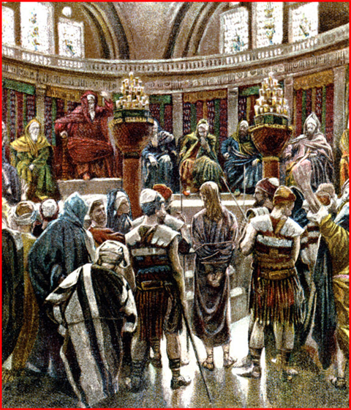
Artist rendering of Jesus standing before the Sanhedrin.

John 18:12-13 Then the detachment of soldiers with its commander and the Jewish officials arrested Jesus. They bound him ¹³ and brought him first to Annas, who was the father-in-law of Caiaphas, the high priest that year.
John 18:24 Then Annas sent him bound to Caiaphas the high priest.

John 18:28-30 Then the Jewish leaders took Jesus from Caiaphas to the palace of the Roman governor. By now it was early morning, and to avoid ceremonial uncleanness they did not enter the palace, because they wanted to be able to eat the Passover. ²⁹ So Pilate came out to them and asked, “What charges are you bringing against this man?” ³⁰ “If he were not a criminal,” they replied, “we would not have handed him over to you.”
John 18:31 “Take him and judge him by your own law.”
Three accusations against Jesus
- This man is guilty of subverting the nation
- This man opposes paying taxes to Rome
- This man claims to be king
John 18:36-37 Jesus said, “my kingdom is not of this world. You are right in saying I am a king. In fact, for this reason I was born, and for this I came into the world to testify to the truth. Everyone on the side of truth listens to me.”
Matthew 2:1 “Where is the one who has been born king of the Jews?”
Things Jesus did say about himself
John 6:35 Then Jesus declared, “I am the bread of life. Whoever comes to me will never go hungry, and whoever believes in me will never be thirsty.
John 8:12 When Jesus spoke again to the people, he said, “I am the light of the world. Whoever follows me will never walk in darkness, but will have the light of life.”
John 10:7 Therefore Jesus said again, “Very truly I tell you, I am the gate for the sheep.
John 10:14-15 “I am the good shepherd; I know my sheep and my sheep know me—¹⁵ just as the Father knows me and I know the Father—and I lay down my life for the sheep.
John 11:25 Jesus said to her, “I am the resurrection and the life. The one who believes in me will live, even though they die;
John 13:14-15 Now that I, your Lord and Teacher, have washed your feet, you also should wash one another’s feet. ¹⁵ I have set you an example that you should do as I have done for you.
John 14:6 Jesus answered, “I am the way and the truth and the life. No one comes to the Father except through me.
Matthew 8:19-20 Foxes have holes and birds of the air have nests, but the Son of Man has no place to lay his head.
Mark 2:28 "The Son of man is Lord even of the sabbath"
John 18:34 Who put you up to asking this? “Was this your own idea or did others talk to you about me?”
The test of integrity is often found in doing the unpopular / right thing.
Every thought we entertain, every action we carry out is developing or destroying our integrity. Integrity matters
- We can be trusted to do what is right. Proverbs 11:3
- We have a good reputation. Psalm 78:72
- We can enjoy peace. Psalm 41:12
- We build the kind of relationships/friendships that benefit our life. Proverbs 13:6; Proverbs 21:21
- We can live with our decisions, even when they are not popular. Clear conscience 2 Corinthians 1:12
- We can enjoy the blessings and security of God. Proverbs 10:9
- We inspire others to be strong and stand for what is right. Living example Titus 2:7
Matthew 27:24 When Pilate saw that he was getting nowhere, but that instead an uproar was starting, he took water and washed his hands in front of the crowd. “I am innocent of this man’s blood,” he said. “It is your responsibility!”
The curtain in the temple was 60’ tall, 30’ wide and approximately 1” thick. It separated the Holy Place (where the candlestick, the altar of incense, and the table of bread were kept) from the Holy of Holies (where the ark of the covenant was kept). Previously only the high priest could enter the holy of holies, once per year, on the day of atonement. But now the way has been opened for all.
Psalm 30:5 “… Weeping may tarry for the night, but joy comes with the morning.”

