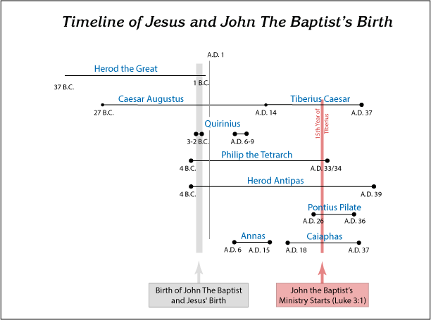

Facts concerning the leaders mentioned in Luke 3
Caesar Augustus 29 BC- AD 14 and Caesar Tiberias AD 14- 37 co-reigned over the Roman empire for a period of time.
Pontius Pilate – ruled as governor of Judea
Herod – ruled as tetrarch of Galilee 37-4 BC (died in 4BC)
Philip (brother of Herod) ruled the region of Ituraea and Trachonitis
Lysanias – ruled as tetrarch of Abilene
Annas and Caiaphas were the High Priests during this period.
Mark 1:1-4 This is the beginning of the wonderful news about Jesus the Messiah, the Son of God. 2 It starts with Isaiah the prophet, who wrote: Listen! I am sending my messenger ahead of you and he will prepare your way! 3He is a thunderous voice of one who shouts in the wilderness: “Prepare your hearts for the coming of the Lord Yahweh, and clear a straight path inside your hearts for him!” 4 John the Baptist was the messenger who appeared in the wilderness, preaching a baptism of repentance for the complete cancellation of sins.
Repentance is translated from the Greek word Metanoia, means a change of mind, sorrow or deep remorse for sin and violating God’s holy law.
1 Corinthians 2:1-5 And I, when I came to you, brothers, did not come proclaiming to you the testimony of God with lofty speech or wisdom. 2 For I decided to know nothing among you except Jesus Christ and him crucified. 3 And I was with you in weakness and in fear and much trembling, 4 and my speech and my message were not in plausible words of wisdom, but in demonstration of the Spirit and of power, 5 that your faith might not rest in the wisdom of men but in the power of God.
Galatians 5:22-23 But the fruit of the Spirit is love, joy, peace, patience, kindness, goodness, faithfulness, 23 gentleness, self-control…
