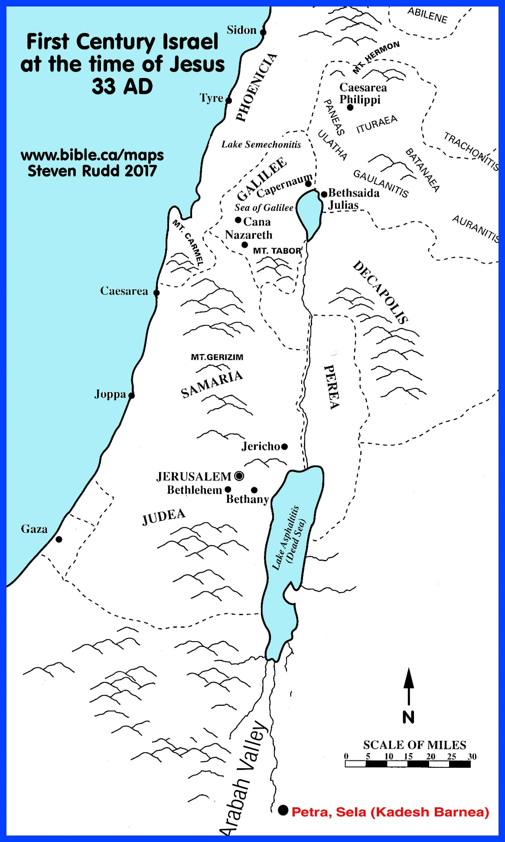
Luke 6:17 He went down with them and stood on a level place. A large crowd of his disciples was there and a great number of people from all over Judea, from Jerusalem, and from the coastal region around Tyre and Sidon,
Genesis 2:2-3 By the seventh day God had finished the work he had been doing; so on the seventh day he rested from all his work. Then God blessed the seventh day and made it holy,
Exodus 20:8 Remember the Sabbath day, to keep it holy.

Blessings/Reward | Woe/Warning
Blessed are the poor/yours is the kingdom of God | Woe to those who are rich/you have already been comforted
Blessed are those who hunger now/will be satisfied. | Woe to you who are well fed now/ you will go hungry.
Blessed are you who weep now/ you will be comforted. | Woe to you who laugh now/ for you will mourn and weep.
Blessed are you when people hate you because of your love for Jesus/ great will be your reward in heaven. | Woe to you when everyone speaks well of you/you have enjoyed the praise of men over the praise of God.

2 Timothy 3:12 All that live godly in Christ Jesus will suffer persecution.
Galatians 5:22-23 But the fruit of the Spirit is love, joy, peace, patience, kindness, goodness, faith, gentleness, and self-control.

