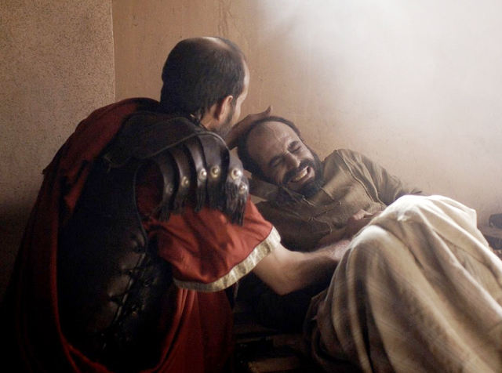
The Centurion sent friends to meet Jesus and relay his message, “Lord, don’t trouble yourself, for I do not deserve to have you come under my roof. That is why I did not even consider myself worthy to come to you. But say the word, and my servant will be healed. For I myself am a man under authority, with soldiers under me. I tell this one, ‘Go,’ and he goes; and that one, ‘Come,’ and he comes. I say to my servant, ‘Do this,’ and he does it.”
Jesus said, “I tell you, I have not found such great faith even in Israel.”

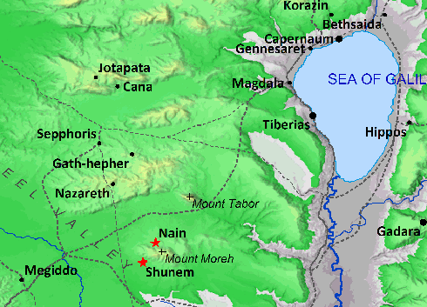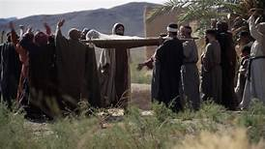

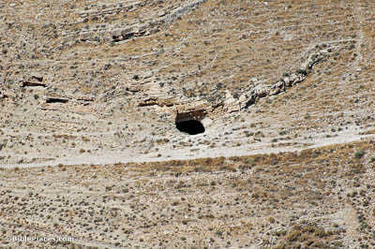

According to one tradition, John the Baptist was being held in this cave at Macherus. But regardless of his location, John was evidently suffering discouragement, even to the point of questioning Jesus’s identity.
To reassure him, Jesus had his disciples report the miracles being done; this would prove to John his Messianic identity, as described similarly in Isaiah 35.

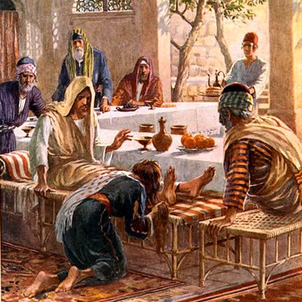
Then turning toward the woman he said to Simon, "Do you see this woman? I entered your house; you gave me no water for my feet, but she has wet my feet with her tears and wiped them with her hair. You gave me no kiss, but from the time I came in she has not ceased to kiss my feet. You did not anoint my head with oil, but she has anointed my feet with ointment.
Therefore I tell you, her sins, which are many, are forgiven--for she loved much. But he who is forgiven little, loves little.
" And he said to her, "Your sins are forgiven."

Psalm 23: 1-6
The LORD is my shepherd; I shall not want. 2 He makes me lie down in green pastures. He leads me beside still waters. 3 He restores my soul. He leads me in paths of righteousness for his name's sake. 4 Even though I walk through the valley of the shadow of death, I will fear no evil, for you are with me; your rod and your staff, they comfort me. 5 You prepare a table before me in the presence of my enemies; you anoint my head with oil; my cup overflows. 6 Surely goodness and mercy shall follow me all the days of my life, and I shall dwell in the house of the LORD forever.
Psalm 23:4
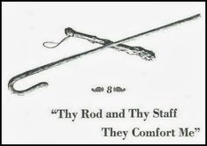
Psalm 23:6

