The kingdom of God is the kingdom of GRACE.

The parable of the sower
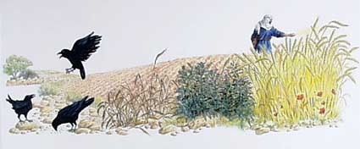

Luke 9:23 “If anyone would come after me, he must deny himself and take up his cross daily and follow me.”
Isaiah 6:1-4 “In the year that King Uzziah died, I saw the Lord, high and exalted, seated on a throne; and the train of his robe filled the temple. Above him were seraphim, each with six wings: With two wings they covered their faces, with two they covered their feet, and with two they were flying. And they were calling to one another: “Holy, holy, holy is the Lord Almighty; the whole earth is full of his glory.”
Isaiah 6:5 “Woe to me!” I cried. “I am ruined! For I am a man of unclean lips, and I live among a people of unclean lips, and my eyes have seen the King, the LORD Almighty.”
Isaiah 6:8 Then I heard the voice of the Lord saying, “Whom shall I send? And who will go for us?” And I said, “Here am I. Send me!”
What is your storm? What miracle would you like to see happen?
Are you going to Jesus with it or simply trying to handle the situation?
What is your testimony, your story? What has the Lord done for you? Are you sharing your story with others? If you are a child of God, a follower of Jesus Christ, you have a story. Jesus wants us to share it!
What do we know about our amazing Savior? He has authority.
He shares truth, brings light, he loves us as his family, he has authority over nature, evil-spirits, sickness, and death.

