Edmond Metro Library 10 S. Boulevard, Edmond
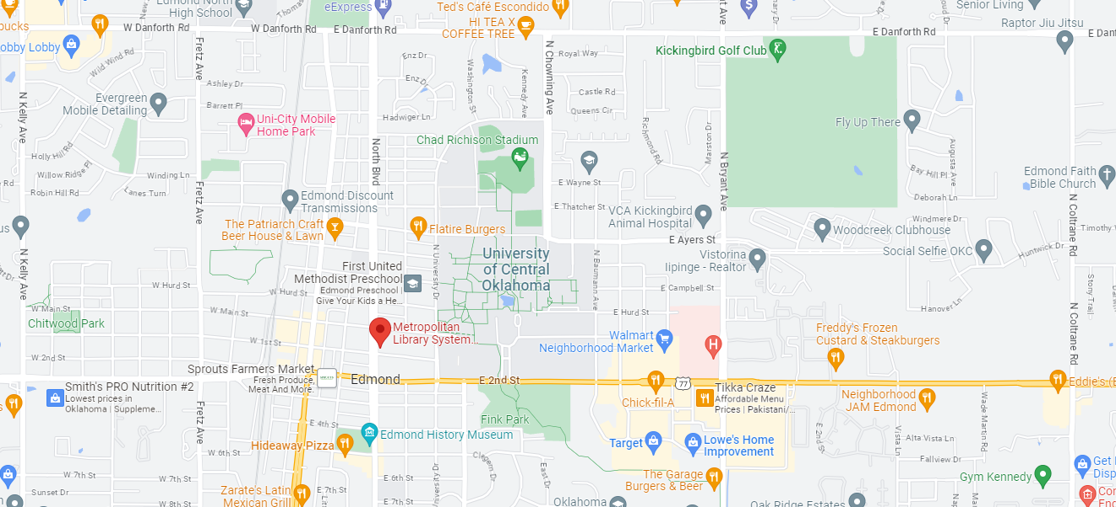

Nehemiah 1:3 MSG “The exile survivors who are left there in the province are in bad shape. Conditions are appalling. The wall of Jerusalem is still rubble; the city gates are still cinders."
It has been 13 years since Ezra led the 2nd group of exiles back.
- Zerubbabel had led the 1st group of exiles back 538 BC, (Ezra 1:1, 1st year of King Cyrus)
- Artaxerxes became king in 465 BC Esther became his queen.
- Ezra had led the 2nd group of exiles back 458 BC (Ezra 7:7 arrived in Jer. the 7th year of King Artaxerxes)
- It is now the 20th year of King Artaxerxes. 445 BC

Trauma therapist Dr. H. Norman Wright speaking on Focus on the Family.
“We are all in the same boat. We are not all in the same storm. For some people, it’s sprinkling. This is a break. It’s a breather. It’s a rest, a pause, a time to reconnect with their families. Honestly, it’s kind of peaceful. But for some others, it’s a storm. It’s a bit scary. It’s disruptive. For some, it’s a hurricane. It’s tearing at boards. It’s pulling off roofs. It’s washing them out to sea.
It’s not wrong to be enjoying a sprinkle or enduring a storm. But please don’t negate the difference. Rest with your family, but don’t minimize the hurricane engulfing your neighbor. Laugh when you can but get on your knees for your friends.”

Nehemiah 1:5-6 Then I said: “LORD, the God of heaven, the great and awesome God, who keeps his covenant of love with those who love him and keep his commandments, 6 let your ear be attentive and your eyes open to hear the prayer your servant is praying before you day and night for your servants, the people of Israel.
LORD is the Hebrew word, Jehovah- The Self-Existent One, who never changes, whose promises never fail, He is faithful to all generations.
God is the Hebrew word, Elohim-The All-Powerful God of the universe, Creator of heaven and earth, who is worthy of all reverence.

Has God spoken to you about repairing something?
What have you been called to repair?
- Fire safety – Stop, Drop, and Roll
- Spiritual safety – Stop, Drop, and Pray!!!!

